Midterm Examinations
Question 1
a).
Macroeconomics refers to a branch of economics that deals with the performance, structure, behavior and decision-making of an economy as a whole. In other words, macroeconomics attempts to measure how the economy operates with an aim to understand what forces drive it while giving an accurate projection on how performance can improve within the economy. The primary goals of macroeconomics includes attaining reliable economic growth as a means of defining the prevailing standards of living and extend of outward shift in the country’s Production Possibility Curve (PPC). Another goal is attaining full employment or ensuring low unemployment. In this regard macroeconomists strives to ensure that people are fully engaged in quite productive work hence making the economy more productive. Macroeconomists are also focused to ensure low inflation or attaining stable process. As evident a sustained increase in the overall level of prices alters the living standards of the people, thus, low inflation rates of less than 5% remains a major goal. Other leading goals include fair distribution of income and maintaining equilibrium in balance of payment.
Currently, Bangladesh has annual inflation rate amounting to 5.64% as of June of 2021. In the recent years, the annual inflation rates include 5.6% in 2020, 5.5 in 2019, 5.8 in 2018, 5.4 in 2017, and 5.9 in 2016, values which have remained relatively higher than the recommended inflation rate of 5%. For that reason, it is worthy to assert that Bangladesh has never had a stable price economy over the past 5 years as defined by data.
b).
National Income = Gross national product +Net Interest + Business Profit + Dividend Income-Depreciation
=4880+392+328+102-513
=5189

Personal Income = Indirect Business Tax + Personal Interest Income+ personal tax and non-tax payments + social security contributions
=394+587+586+444+571
=2582

Disposable personal income = Personal Income -Personal Tax and Non-tax payment
=2582-586
=1996

c).
I disagree with the statement. Basically, labor force implies the sum of employed and unemployed persons in an economy. Generally, unemployment rate is obtained as the ratio of the number of unemployed persons to the number of the employed persons expressed as a percentage. Current studies have shown that unemployment is going to be a leading challenge in Bangladesh because the number of unemployed persons is rapidly increasing as opposed to the number of those employed. There is need to address this issue.
Question 2
The three sectors of the circular flow include business, household, and government. In the household sector, individuals are committed to meet their endless wants hence consumption expenditures. Business sector is committed to combining resources to produce goods and services and hence they spend on capital goods with investment expenditures. Government on the other hand majors on passing laws collecting taxes, and forcing other sectors to meet the requirements voluntarily. The expenditure approach to GDP entails accurate combination of consumption, investment, government spending, and net exports.
Question 3
Disequilibrium unemployment is caused by growth in labor supply. Equilibrium unemployment is the variation amid those interested to work and those who are willing and able to take a job at current wage rate.
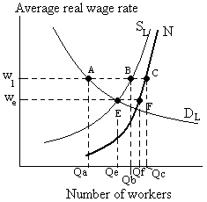
Frictional unemployment occurs as a result of voluntary employment transitions within an economy and it mostly occurs in stable economy.
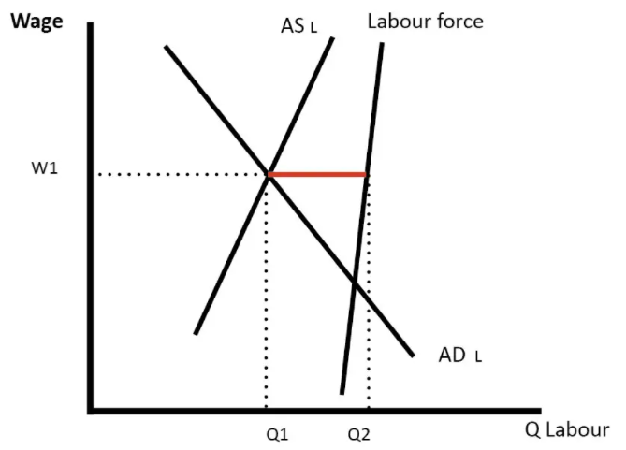
Equilibrium unemployment on the other hand takes place when the labor market is at equilibrium, thus, jobs are available but people are not willing or are unable to take jobs that exists.
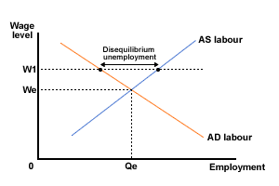

Question 4
GDP is the measure of the total value of goods and services produced within a country’s borders either by citizens or non-citizens. GNP measures the value of goods and services produced by only a country's citizens but both domestically and abroad. GDP is the most commonly used by global economies. To calculate GNP is to take the GDP figure, plus net factor income from abroad. All data for GNP is annualized and can be adjusted for inflation to produce real GNP. In my understanding, Hamid’s Income is not included in Bangladesh’s GDP because he does not earn or produce within the country’s boundaries.

